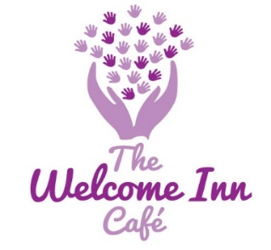
The Welcome Inn Café
Bournemouth Methodist Church @ Victoria Park
Edgehill Road, Bournemouth, BH9 2QG
07525 770565
welcomeinncafe@gmail.com

** We are now recruiting volunteers **
Your precious time – weekly, fortnightly, or occasionally – would be of a great help!
Please consider our plea and if you would like to support this project, contact Amy using the email address above with your availability
We firmly believe that The Welcome Inn will be a beacon of hope, a safe place for new friendships and a source of support for a lot of people and groups who have endured isolation, hardship, and lack of support over the pandemic as well as with all these austerity measures in place.
Do spread the word to your friends and neighbours who may want to volunteer as well!
Name:
Contact Number:
Email Address:
Additional Information:

I would be available to help (please tick or state the times you are available)

 | Weekly | Fortnightly | Monthly | Occasionally to  cover absence | Other ways  (advertising, fundraising, etc.)
Monday
Tuesday
Wednesday
Thursday
Friday
Saturday

Please complete your availability and return to: welcomeinncafe@gmail.com Thank you

